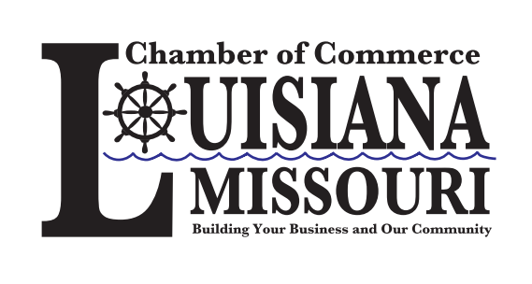
2025 Louisiana Country Colorfest
Parade Sign – up Form

Mail or E-mail your completed form: (All sign-up forms must be filled out fully and signed)
Louisiana Chamber of Commerce P.O. Box 542 Louisiana, MO 63353 Info@louisianamochamber.com
Questions? Call: (573) 253-5201
Event Details:
Saturday October 18, 2025 -Parade line-up starts at 9:00 A.M. – Parade starts at 10:00 A.M.
Motorized vehicles line-up at the High School - Parade Walkers line-up at Sunset Park
No fee to participate
Parade Theme: Paddlewheel to Progress
(depicting the journey from steamboats and trading posts to modern-day prosperity)
Parade Awards Categories:
- Grand Marshall’s Choice
- Spirit of the Parade
- Best of Show Float
Band Award Categories:
- Best Band Award
- Best Color Guard Award
- Battle of the Bands Competition
The Battle of the Bands Competition and Parade Award Ceremony will be held at the Main Stage (Intersection of 4th Street & Georgia Street) immediately following the Parade
Participant Information:
Contact Person: ________________________________________________________
Organization/Group Name: ______________________________________________
Phone Number: _________________________________________________________
Email Address: __________________________________________________________
Category: (please select one)
Band Walker Float Car Showcase Other: _____________

Parade Participant Rules and Regulations:
- The Louisiana Chamber of Commerce and/or Colorfest Committee are NOT liable for any accidents or damage done to floats or vehicles; furthermore, none of the above are responsible for falls or injuries of any type.
- No Pyrotechnics or Fireworks allowed.
- Max Speed for Parade Participants is 5 mph.
- All motorized entries must enter the parade route from Louisiana High School
- Walkers will join the parade route at Sunset Park.
- All floats and Entries will keep distance of two car lengths between them and the float or vehicle in front of them.
- Participants are not allowed to throw candy or other objects into the crowd.
- Participants are not allowed to spray the crowd with any substance, including water.
- Walkers are not allowed to physically touch anyone in the crowd or other participants.
- Walkers are to be at least 16 years of age or accompanied by a parent or adult.
- NO ALCOHOL during parade.
- Horse riders must be over the age of 16 years old, if not they are required to wear protective headgear and must be accompanied by a parent or adult.
- All floats with children under the age of 16 require parental or adult supervision.
- All floats with riders under the age of 16 shall have safety rails.
- Drivers of any vehicle in the parade must be a licensed driver over the age of 16 years.
- No Stunts or Racing maneuvers.
- Horses and Large Motorized Vehicles are to Exit Right onto 7th street BEFORE entering the Colorfest Festival area.
Release of Liability:
I, the undersigned, hereby acknowledge and agree to the following:
- Assumption of Risk:
I understand that participation in the Louisiana Chamber of Commerce Colorfest Parade involves certain risks, including but not limited to the risk of personal injury, property damage, or other unforeseen hazards. I voluntarily assume all such risks associated with participation in this event.
- Release and waiver:
In consideration of being permitted to participate in the parade. I, on behalf of myself, my heirs, assignees, and personal representatives hereby release, waive, discharge and covenant not to sue the Louisiana Chamber of Commerce, its officers, directors, employees, volunteers, or any other participants in the event, from any and all liability for any claims, demands, actions, or causes of action arising out of or related to any loss, damage or injury, including death, that may be sustained by me, or any property belonging to me, whether caused by negligence or otherwise, while participating in the parade.
- Indemnification:
I agree to indemnify and hold harmless the Louisiana Chamber of Commerce, its officers, directors, employees, volunteers, or any other participants in the event from any and all claims, actions, suits, costs, expenses, damages, and liabilities, including attorney fees, arising out of or resulting in my participation in the parade.
- Prohibition of Object Throwing/Launching

I understand and agree that no objects of any kind are to be thrown or launched into spectators during the parade. I accept full responsibility of any incidents that may arise from violating this rule.

- Acknowledgment of Understanding:

I have read the Parade Rules and this Release of Liability in its entirety and fully understand its terms and conditions. I agree to abide by the terms of this agreement. I understand I am signing it freely and voluntarily, and that by doing so, I am giving up legal rights and remedies.

Printed Name:___________________________________
Signature:_______________________________________
Date: ___________________________________________

